NATIONAL FEDERATION OF YOUNG FARMERS’ CLUBS
Status Final
May 2023
Area Eliminator

Competitions Programme 2023-2024

NFYFC Tug of War Championships
(Ladies, Men’s and Junior GENSB Competitions)
Following the Tug of War Association Competition Rules, 2011; incorporating TWIF Rules
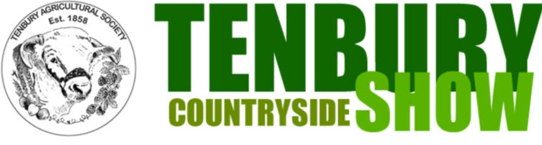
R U L E S
COMPETITION AIM
To encourage YFC members to work together as a team to demonstrate their Tug-of-War skills in a competition environment.

LEARNING OUTCOMES
Tug-of-War skills: strength, rhythm, pulling position and technique; teamwork, respect, discipline, enjoyment, sportsmanship as well as providing health and wellbeing benefits.

REMINDER: Please read these rules in conjunction with NFYFC General Rules and familiarise all competitors with the Fine System in place for withdrawal from competitions.
Further information can be found at https://nfyfc.org.uk/competition-organisers-resources

For insurance purposes all rounds of competition must be held using a Tug of War Association (ToWA) judge and under the authority of a Tug of War Association permit (available from the Hon. Gen. Sec. of the ToWA). Further guidance can be obtained from the official Tug of War Association Handbook or ToWA website.

These rules are for the NFYFC final but may be adapted for county and area rounds with agreement from the chief judge. Counties and areas may wish to pull in a straight knockout competition or pull according to the pre 2011 ToWA rules.

- DATE & VENUE
  - After the area finals, the final will be held at Tenbury Show on Saturday 4th August 2024.
- REPRESENTATION
  - Counties may enter one team entry per 600 members or part thereof in Area Finals.
  - Areas will be represented by one County team per 3,000 members or part thereof in the Competition Final. (Northern Area 2, Eastern Area 1, East Midlands 1, West Midlands Area 1, South West Area 2, South East Area 1 and Wales 2)

- SUBSITIUTION PRIOR TO THE COMPETITON
3.1 All substitutes must have been eligible to compete in the County Final.

- ELIGIBILITY
  - Ladies and Men’s teams shall consist of eight pulling members of the same gender. No more than two (2) members of a team may be between the ages of 15 and over, and under 17 years on 1 September 2023 and the remainder of the team MUST be between 17 years and over, and 28 years of age or under on 1 September 2023.
  - A Junior GENSB team shall consist of between 7 and 10 pulling members, male or female, who must be between 12 years & 17 years of age and under on 1st September 2023. This means competitors MUST have attained their 12th birthday on 1st September 2023 and may be 18 on the day of the competition.

  - All competitors must be full members of a Club affiliated to the NFYFC (You cannot compete for more than one club and county in one membership year). Competitors at the National Final must both present their YFC membership card and also, if over 18, have additional official photographic ID (Passport or Driving Licence).
  - Coaches and Trainers – Only one Coach is permitted with each team during pulling. Only one Trainer or “Water-Carrier” is permitted with each team. During pulling the Trainer shall take up position well clear of both teams and is not permitted to address any remark to them during actual pulling. Neither the Coach nor Trainer need comply with other rules of eligibility.

- REPLACEMENT PULLERS
  - All replacements must have been eligible to compete in the County Final.

- WEIGHING-IN PROCEDURE AND WEIGHT LIMITS
  - Teams will be notified of Weighing-in and report times prior to the NFYFC final.
  - The 8 members of the Ladies or Men’s teams will be weighed as one and will not exceed:
Men - 680 kg Ladies - 560 kg
  - The members of the Junior GENSB team will be weighed as one with the initial weight limit of:
Junior GENSB - 560kg
An additional 10kg will be added to the weight allowance for each female in the team up to a maximum of 600kg

  - The competitors will be stamped or marked on a limb in a position easily seen by the Judge, but not easily erased by the rope or competitors clothing.
  - At weigh-in all team members must have their boots available for inspection by the judges.

- SUBSTITUTION ON THE DAY OF THE COMPETITION
  - After a team has pulled the first end of the first match, the team is able to use a substitution. A substitute may replace any one puller for the remainder of the competition (Age restriction of team still applies). Substitution may be used for tactical reasons or due to injury.
  - Any potential substitutes must (unless otherwise instructed by competition organisers) have been signed in and had their membership card checked prior to pulling in the competition.
  - At the time of substitution; both, the puller to be replaced and the substitute, must report in full pulling outfit, (shirts, shorts, stockings and footwear) to the Chief Judge/Chief Steward who may designate an official to deal with the substitutes. A small (bathroom type) scale must be available at the pulling area, (in a suitable place, on solid surface), to determine the weight difference between the two pullers. The substitute puller must be of equal weight or less than the puller he/she replaces. Directly after the change, the Chief Judge or designated official shall cancel the stamp or marking of the replaced puller, and indicate a similar marking on the substitute, with an indelible marker. This change shall then be recorded.
N.B For GENSB teams; Once weighed in, the team weight allowance cannot be improved upon through substitution i.e. increasing the number of females on the team. Any weight bonus must be removed accordingly if the number of females has decreased below the original bonus threshold of the team.

Eg. Team = 5 males & 4 females = 600kg (560kg + 40kg bonus). A female puller of 70kg is substituted for a male.
The male must weigh 60kg or less (Both in full pulling gear) because the resultant bonus has decreased.

- DRAW AND BYES
  - The Chief Judge and Chief Steward will confirm the number of leagues teams shall be drawn into. However there shall be no more than 7 teams in one league.

- PULLING
  - Each team shall pull a match of 2 ends against every other team in the league with points awarded as follows:
3 points to the winners in a straight pull (two straight pulls)
Nil points to the losers in a straight pull
1 point to each team winning 1 pull each

Note: If teams are drawing on points at the end of the league; they shall be ranked using the following system until differentiation:
- Results of matches (between the teams drawing on points).
- Matches won (most matches won).
- Cautions (least number throughout pulling).
- Team weight (lowest team weight at weigh in).
- Coin toss or draw.

  - If there is one league; the top 4 teams on points shall enter the semi-final competition as follows: 1st v 4th; 2nd v 3rd
  - If there are two leagues; the top 2 teams on points from each league shall enter the semi-final competition as follows: League one winner v League two runner up League two winner v League one runner up
  - The losers of the semi-finals shall pull off for 3rd and 4th places before the winners of the semi-finals pull off for 1st and 2nd places.
  - The semi-finals, 3rd/4th pull off and the final matches shall be won by two (2) pulls out of three (3).

- AWARDS
  - Perpetual Shields and Prize Cards to the winning teams.
  - Prize Cards to teams placed 2nd to 4th
NFYFC Certificates will be awarded to all members of teams competing in the NFYFC finals.

